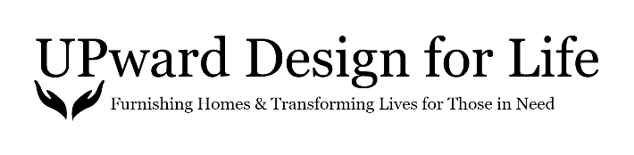
2018 Year-End Review

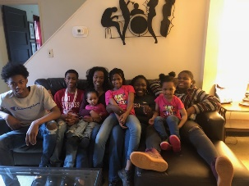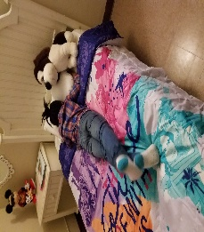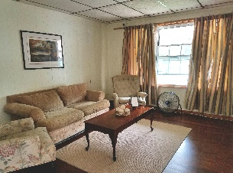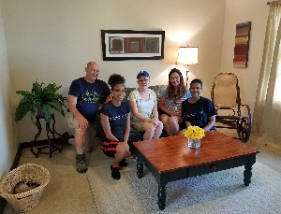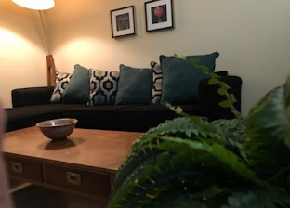

What a wonderful first year for UDFL! We are beyond grateful for all the support we received!

Here are some highlights of the year:
-Gained The Family Justice Center, Western New York Independent Living, Child & Family Services, Erie County Social Services, Access to Psychiatry Through Intermediate Care (APIC), Endeavor Health, Buffalo City Mission/Cornerstone Manor, and My Place Home as new Non-Profit Partner Agencies.
-Served 16 individuals/families in need.
-Received financial contributions, from the general public, totaling $7,948.84
-Received corporate financial contributions totaling $1,367.00.
-Received gifts-in-kind totaling $2,230.87
-Received roughly over $30,000 in donations of new or gently used furniture and accessories.
-Received media attention from Spectrum News, Channel 4, Medaille College Magazine and Buffalo Magazine.
-Obtained a 3,500 square foot warehouse space for storage within the 8 Days of Hope warehouse on Kensington Ave.
-Gained 30 volunteers.

Areas to improve:
-Researching grant opportunities. We are working to bring on a new Board member with grant writing experience. We currently have a list of grants we will apply for in 2019.
-Growing our Board. We are on an on-going search to grow our Board with members who possess the skills we are looking for to help the organization advance successfully.
-Reducing truck rental expenses. Will work to reduce costs associated with renting trucks for donation pick-ups.

The 2019 year ahead:
The UDFL President and Board of Directors will work to establish a three-year strategic plan that will guide our efforts moving forward.
As always your continued support of our efforts are greatly needed. Please consider making a financial contribution today by clicking on the Take Action tab of our website: www.upwarddesignforlife.org.

Thank you!
UPward Design for Life Board of Directors

